DEBUNKING CHARLIE KIRK’S ARGUMENT
@thecubejsablover (TikTok)
Make sure to check out some of my other debunk (Fav -> Collection)
Ok so charlie kirk has these talking points he always brings up about trans. Im just gonna go through what he says cause its the same few arguments every time and i think theres better ways to respond than what people usually say.

He always starts with "feelings dont determine reality" and yh I agree with part of that? If i feel tall that doesnt make me taller, if i feel rich my bank account doesnt magically fill up. But the thing is no trans person is actually saying that. Were not claiming feelings rewrite chromosomes or change what happened biologically. What were saying is that gender identity is a real psychological part of a person. We got minds and personalities and emotions and identities and all that stuff is part of reality too. If someone has anxiety or ptsd or chronic pain we dont go "your feelings dont determine reality" we get that their experience is part of reality. Same thing applies here. So when Charlie says that hes arguing against a strawman nobody really made.

Then he goes "a biological male cannot become a biological female" and like, duh wtf? Most trans people would agree. A trans woman doesnt claim she was born female, thats why the word transgender exists in the first place. The whole point is that someones gender identity is diffrent from their birth sex. But just proving that biology exists doesnt answer the actual question which is whether gender identity matters and if society should recognize it. Its like someone saying "an adopted parent isnt a biological parent" okay true, but that doesnt settle the conversation about whether adoptive parents are real parents in a social or legal sense. Proving biological sex exists doesnt automaticly settle every question about identity or language or legal status.

His most famous one is "what is a woman?" and I gotta admit its a strong rhetorical move cause a lot of people give bad answers. Someone says "a woman is anyone who identifies as a woman" and then mr. kirk points out thats circular, and hes not wrong about that specific answer being weak. But that doesnt mean theres no better answer. A more sophisticated take is that the word woman can mean diffrent things depending on context. In biology it usually means female sex, but in social life it can refer to a gender category tied to identities and experiences and expectations. We do this with words all the time. Ask "what is a parent?" and the answer changes if youre talking biology vs law vs adoption vs family dynamics. Having multiple definitions doesnt mean the concept is meaningless.
(Fun fact : He said the same thing about queer, see his YT channel )

Then he says "gender isnt real, only biological sex is real" which assumes that for something to be real it has to be biological. But, money is real, citizenship is real, marrige is real, laws, languages, all that stuff is real even tho its not a physical object that exists independantly of human society. They're social realities. Gender is often understood in a similar way. You can disagree with that understanding but you cant just dismiss gender as fake because its not purely biological, that doesnt logically follow. Humans create alot of categories that have real consequences even if they arent based in biology.

He also says "reality is objective" and i agree with that, reality is objective. The dissagreement is over what counts as reality. Charlie talks like biology is the only objective reality that matters, but psychology is also real. If someones grieving, that grief is real. If someone has anxiety, that anxiety is real. If someone has gender dysphoria, that experience is real. You dont have to agree with every conclusion drawn from those experiences to acknoledge they exist. The question isnt whether the experience is real, its how society should respond to it.

Then theres "transgender ideology denies biology" and sure some activists might say stuff that seems like theyre denying biological differences, but many trans people dont. A lot of us openly acknoledge biological sex exists, that males and females differ biologically, and that biological sex can matter in some contexts like sports or medicine. The disagreement is usually about whether biological sex should be the only factor considered in every single situation. Treating every supporter of trans rights as if they deny biology is oversimplifying a much broader range of views.

Another one he throws out is "if gender is socially constructed why cant people change race?" and at first glance it sounds like a good comparison but it falls apart when you look at how race and gender actually function in society (lol). Gender roles and expectations have existed in basicly every human culture throughout history, and trans identities have been documented across diffrent societies and time periods. Race by contrast is generally tied to ancestry and family history and historical experiences connected to specific populations. A trans woman isnt claiming to have been born female, but a person claiming to be another race is often claiming membership in a group defined partly by ancestry and inherited historical experiences. The categories work diffrently so the comparison doesnt really hold up ._.!
(Also if you’re saying this is a weak argument, I’m working on a full documentary debunk ~100 transphobes argument/claim, and I’ll include this argument there)

Finally he says "youre putting feelings above facts" but no, most trans advocates arent arguing for feelings instead of facts. They r arguing that psychological facts are also facts. Humans are complicated, we’re biological creatures, psychological creatures, social creatures. Any serious understanding of human identity has to take all three into account. Reducing people solely to chromosomes is just as incomplete as ignoring biology altogether. The strongest pro-trans position ain’t “biology doesn't matter”; it's more like both 3 of them : biology, psychology, and society matter. Understanding human beings requires looking at all three rather than pretending only one of them exists.

For those people who said I’m usign AI :

(Textguard AI checker)
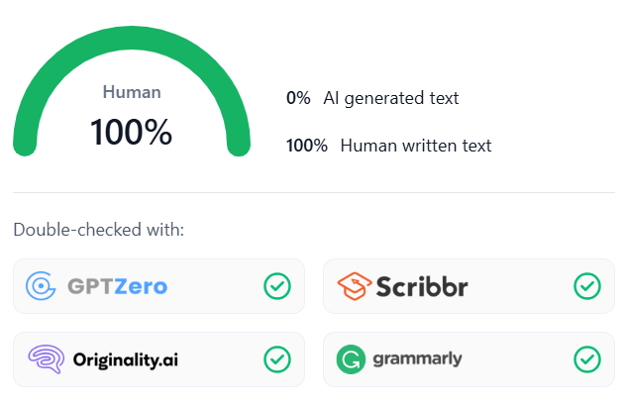
(Aidetector.com AI checker)
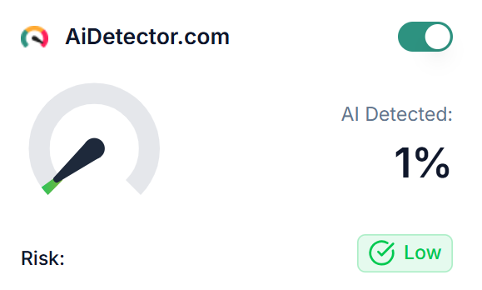
(Phrasly.ai AI checker)
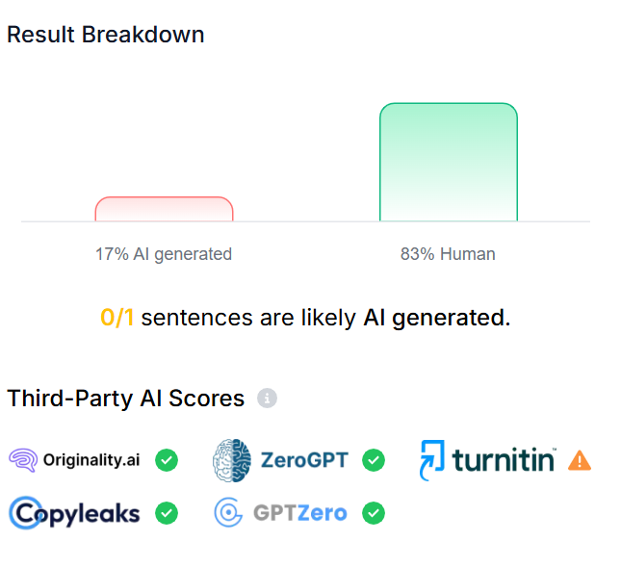
(GPTZero AI checker)
